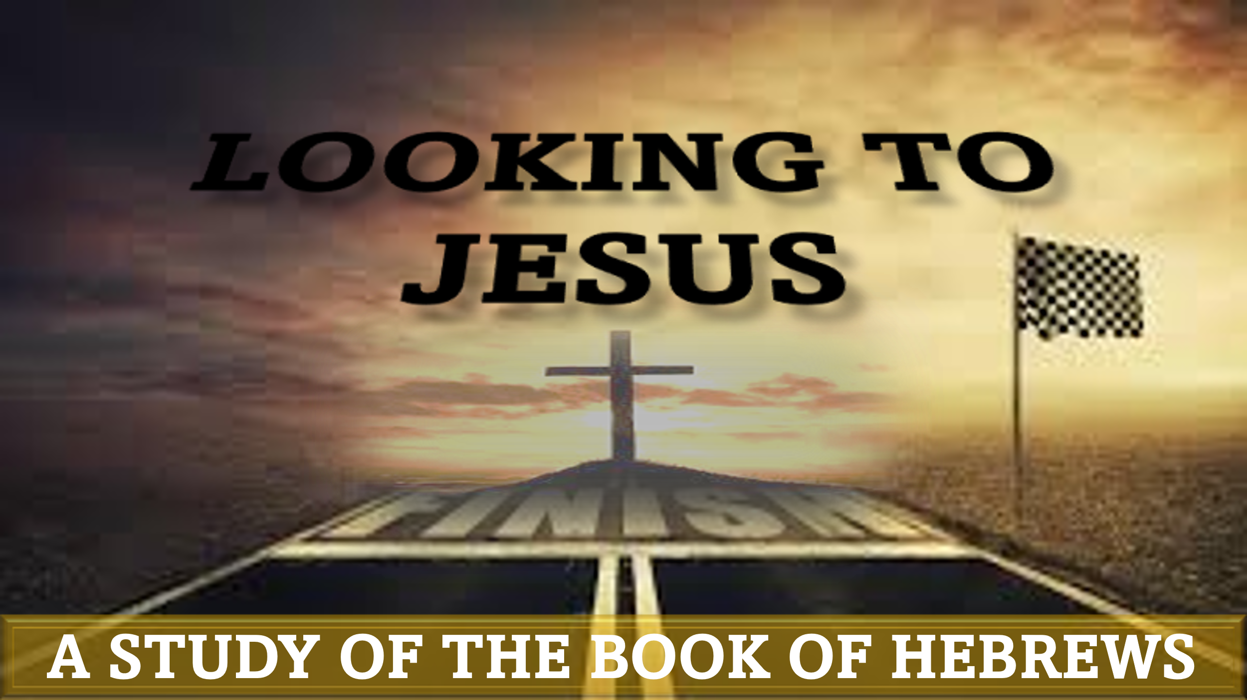

“By Faith: The children of israel”
hebrews 11:28-30

“By faith he kept the Passover and sprinkled the blood, so that the Destroyer of the firstborn might not touch them. By faith the people crossed the Red Sea as on dry land, but the Egyptians, when they attempted to do the same, were drowned. By faith the walls of Jericho fell down after they had been encircled for seven days.”

Every nation or people group venerates pioneering heroes to whom they attribute the founding of their civilization. For the United States, we were taught that George Washington, Thomas Jefferson, and Benjamin Franklin, among others, are responsible for the foundation of our nation. For black people, we look at Frederick Douglas, Harriet Tubman, Nate Turner, and others as pioneers for our freedom. For Israel, two men stand out as champion-leaders in the burgeoning era of their conquest of the Promised Land. These two men are Moses and Joshua.
Tonight’s lesson focuses on 3 major events that led to the nation of Israel escaping the oppression of Egypt and defeating the inhabitants of Canaan in order to settle in the land God had promised to them.
In the history of black people in America, there are some seminal events that have resulted in our survival for centuries in a nation that has been historically hostile to our community. Like Israel, our very existence can be attributed to the faithfulness of our God and the faith of our ancestors.

A Miracle at Midnight – Hebrews 11:28
Midnight is usually understood metaphorically as a time of great testing and trust. Samson destroyed the temple of Dagon, along with the Philistines inside, at midnight (Judges 16:3). Boaz discovered Ruth laying at his feet at midnight (Ruth 3:8). In Jesus’ parable about the 10 wise and 10 foolish virgins, the bridegroom arrived at midnight (Matthew 25:6). Paul and Silas prayed and sang praises in prison at midnight (Acts 16:25).
The first major event to occur at midnight in scripture is found in Exodus 11-12, where God informs Moses that He will dispatch a death angel to kill the firstborn in every household in Egypt at that ominous hour. Moses provides instructions to the Israelites on what they must do to protect their homes from this pending doom (Exodus 12:1-28). Because of Moses’ faith in God’s Word, he obeyed the command and saved his people.
Question 1: What acts of faith were performed by your ancestors that led to the survival of your family, community, church?

A Rescue at the Red Sea – Hebrews 11:29
Has God ever done something miraculous in your life, only to lead you to what appeared to be a dead end? Many of us can review our faith journey and recall times when we felt that God had delivered us from danger, only to discover that an even bigger test was ahead.
After God delivered Israel from Egyptian dominance through 10 mighty acts, they probably felt that the worst was over. However, they soon found themselves in another predicament that appeared to be hopeless. It took the bold faith of Moses to calm them down and lead them to safety (Exodus 14)
Question 2: Why does God sometimes allow us to face increasingly difficult tests in our lives?

A Jubilation at Jericho – Hebrews 11:30
For black Americans, it is common for us to look back at the heroic faith of our ancestors with admiration. However, if all of our stories of overcoming and our heroes are from yesterday, we risk losing appreciation for God’s involvement in our contemporary struggles. It is essential that each generation has their own first-hand testimony of God’s faithfulness.
Although Israel’s triumphant history can be ascribed to those of Moses’ generation, it was important for their descendants to have their own testimony of God’s faithfulness.
Question 3: What unlikely outcomes has God caused in your life that you can share with younger generations in order to strengthen their faith?

Application: God’s faithfulness to us throughout our history must be preserved and shared with those coming behind us in order to maintain our foundation of faith.

