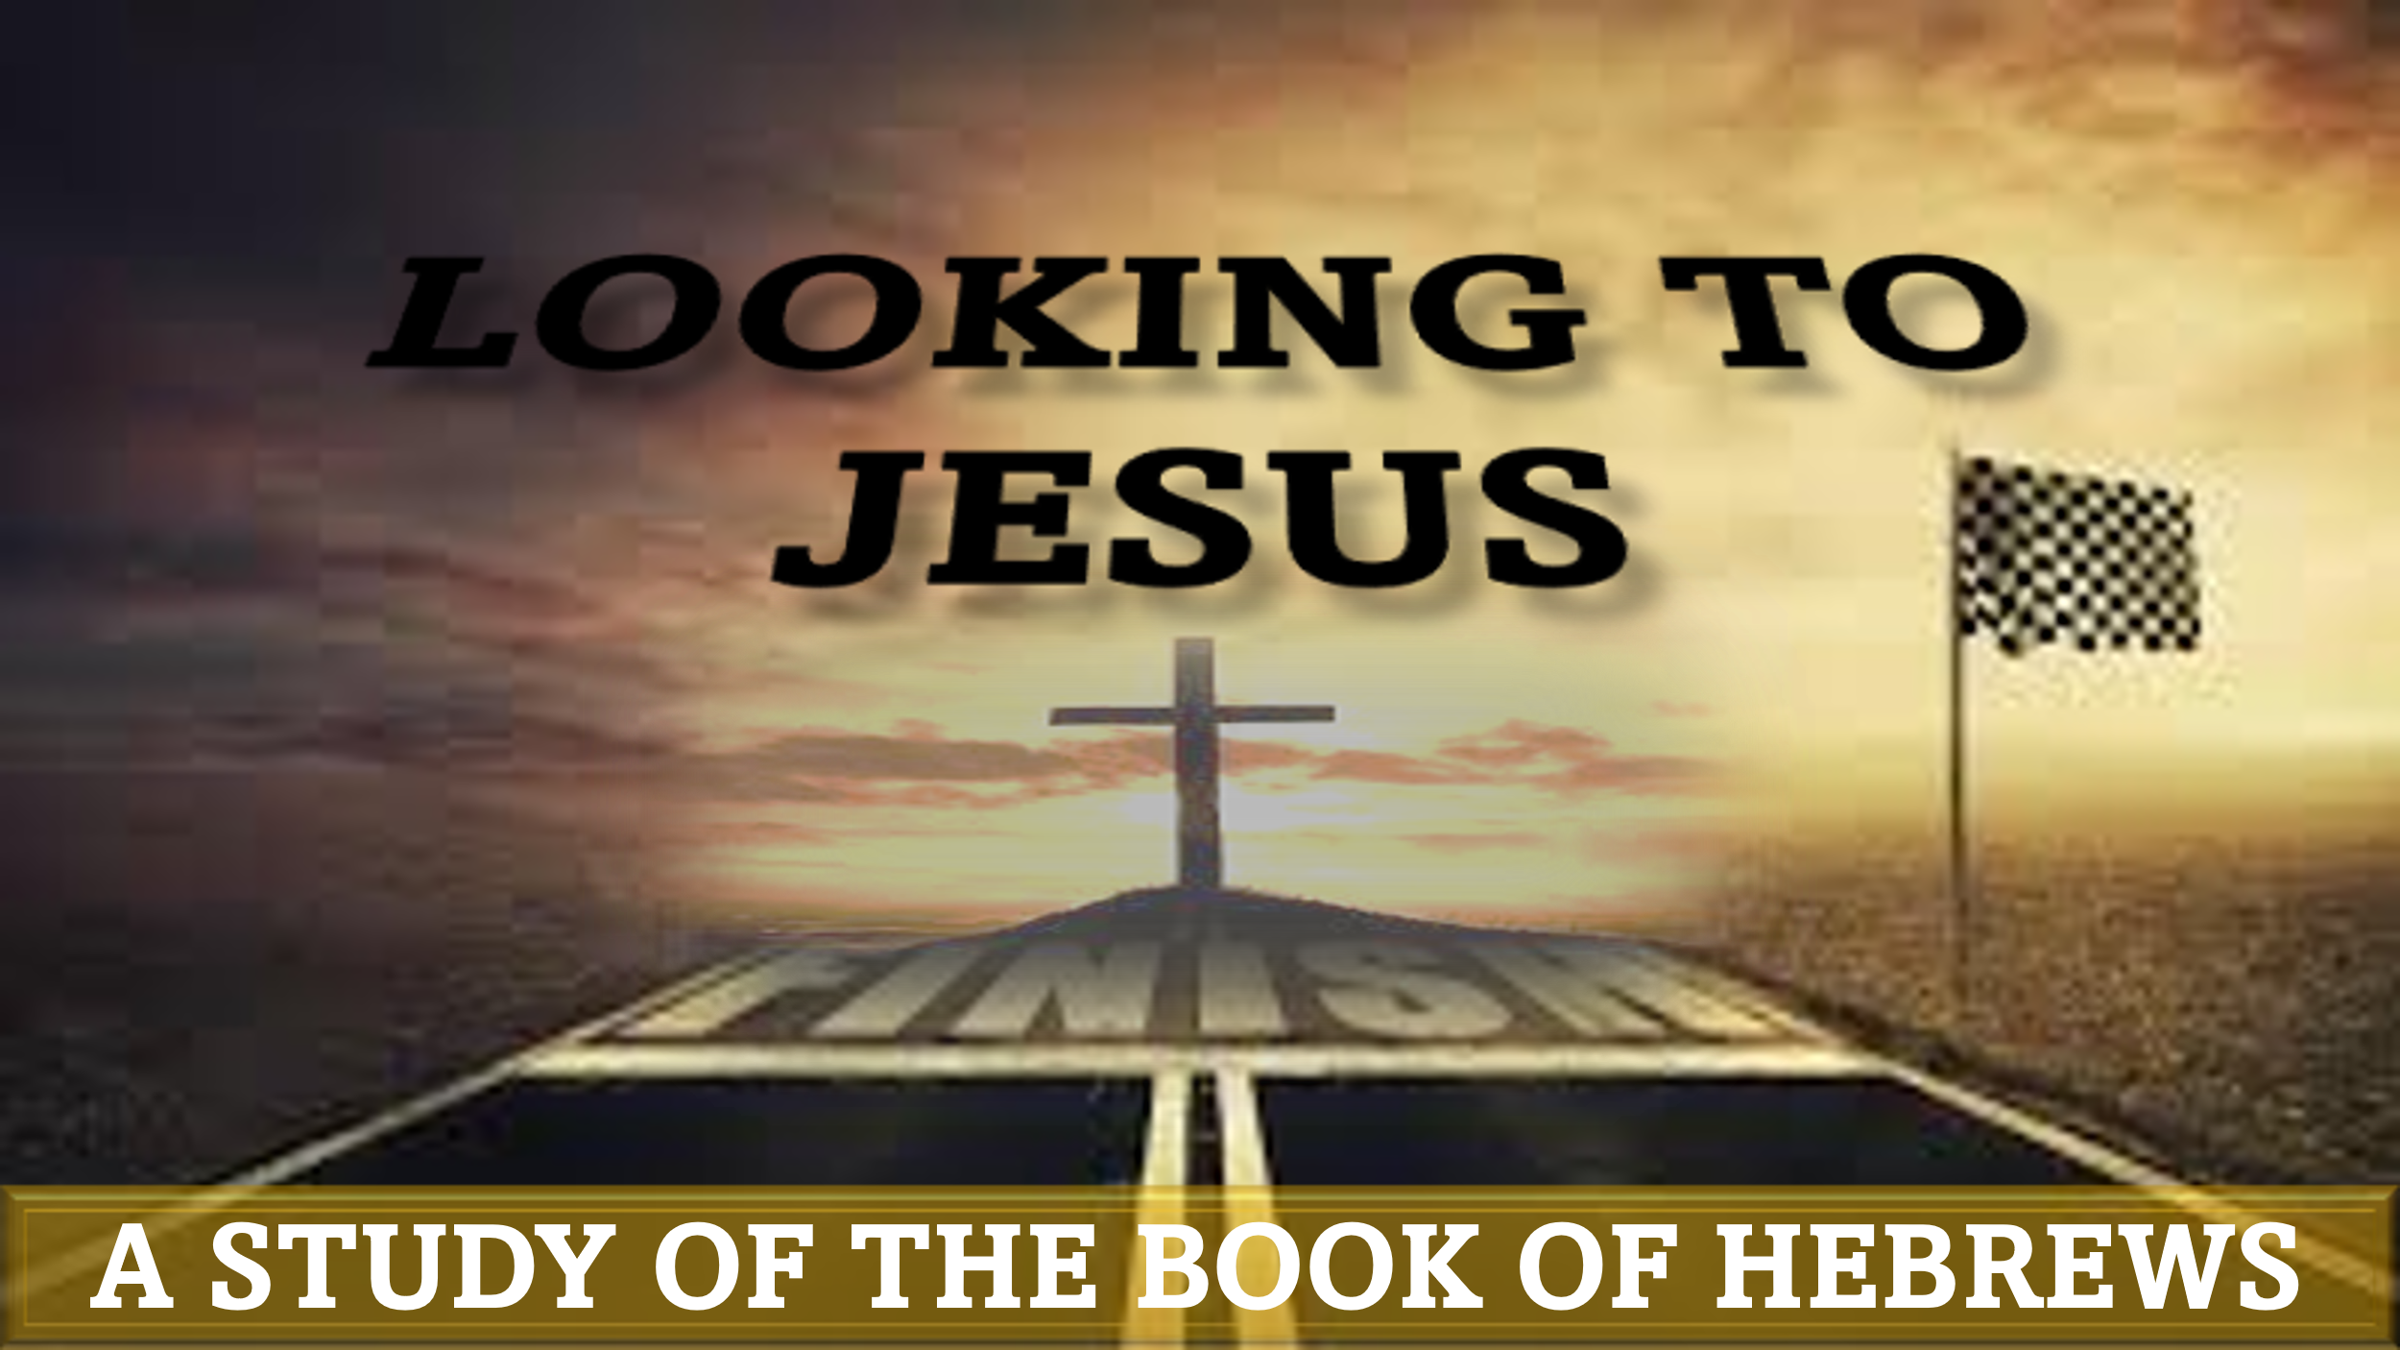
“By Faith: Noah”
hebrews 11:7

“By faith Noah, being warned by God concerning events as yet unseen, in reverent fear constructed an ark for the saving of his household. By this he condemned the world and became an heir of the righteousness that comes by faith.”

Can God use you to do something that has never been done before? Do you trust God enough to obey?
“By faith Abel offered to God a more acceptable sacrifice than Cain, through which he was commended as righteous, God commending him by accepting his gifts. And through his faith, though he died, he still speaks. By faith Enoch was taken up so that he should not see death, and he was not found, because God had taken him. Now before he was taken he was commended as having pleased God.”
Is God pleased with your life? Is your service to God guided by faith or fear? In this study, we will examine the lives of the first two men commended for their faith in Hebrews 11: Abel and Enoch. We will seek to understand how these men pleased God and how we can follow their examples to have the same testimony.

Abel – Genesis 4:1-16
In Genesis 4, we are told that Abel and his brother Cain both offered sacrifices to God. Cain’s offering was from the field, and Abel’s offering was from the flock. According to the narrative, God “had respect” for Abel’s offering, but not for Cain’s. Because his offering was not respected like his brother’s, Cain allowed envy to cause him to kill his brother. Read Matthew 23:35 and Hebrews 12:24
Question 1: Why did God accept Abel’s offering and not Cain’s?

- ENOCH – GENESIS 5:18-24
According to Genesis 5, Enoch was the father of Methuselah and lived for a total of 365 years before he was “taken” by God. Read Jude 1:14-16
Question 2: What was so unique about Enoch’s life that God allowed him to avoid death?

Personal Pondering:
- What can I learn from Abel and Enoch to help me in my faith walk with God?
- How has my faith impacted my life (decisions, relationships, priorities, philosophy, etc.)?
- Is God pleased with me? Why or why not?

Application:
By observing the lives of Abel and Enoch, it is clear that God is impressed not by function, but by faith. Therefore, we must focus more on our motive than our method.

Challenge:
Step outside of your comfort zone and trust God to honor your sincere desire to please Him

“What are you doing that it will take faith to accomplish?” – Dr. E. Edward Jones

