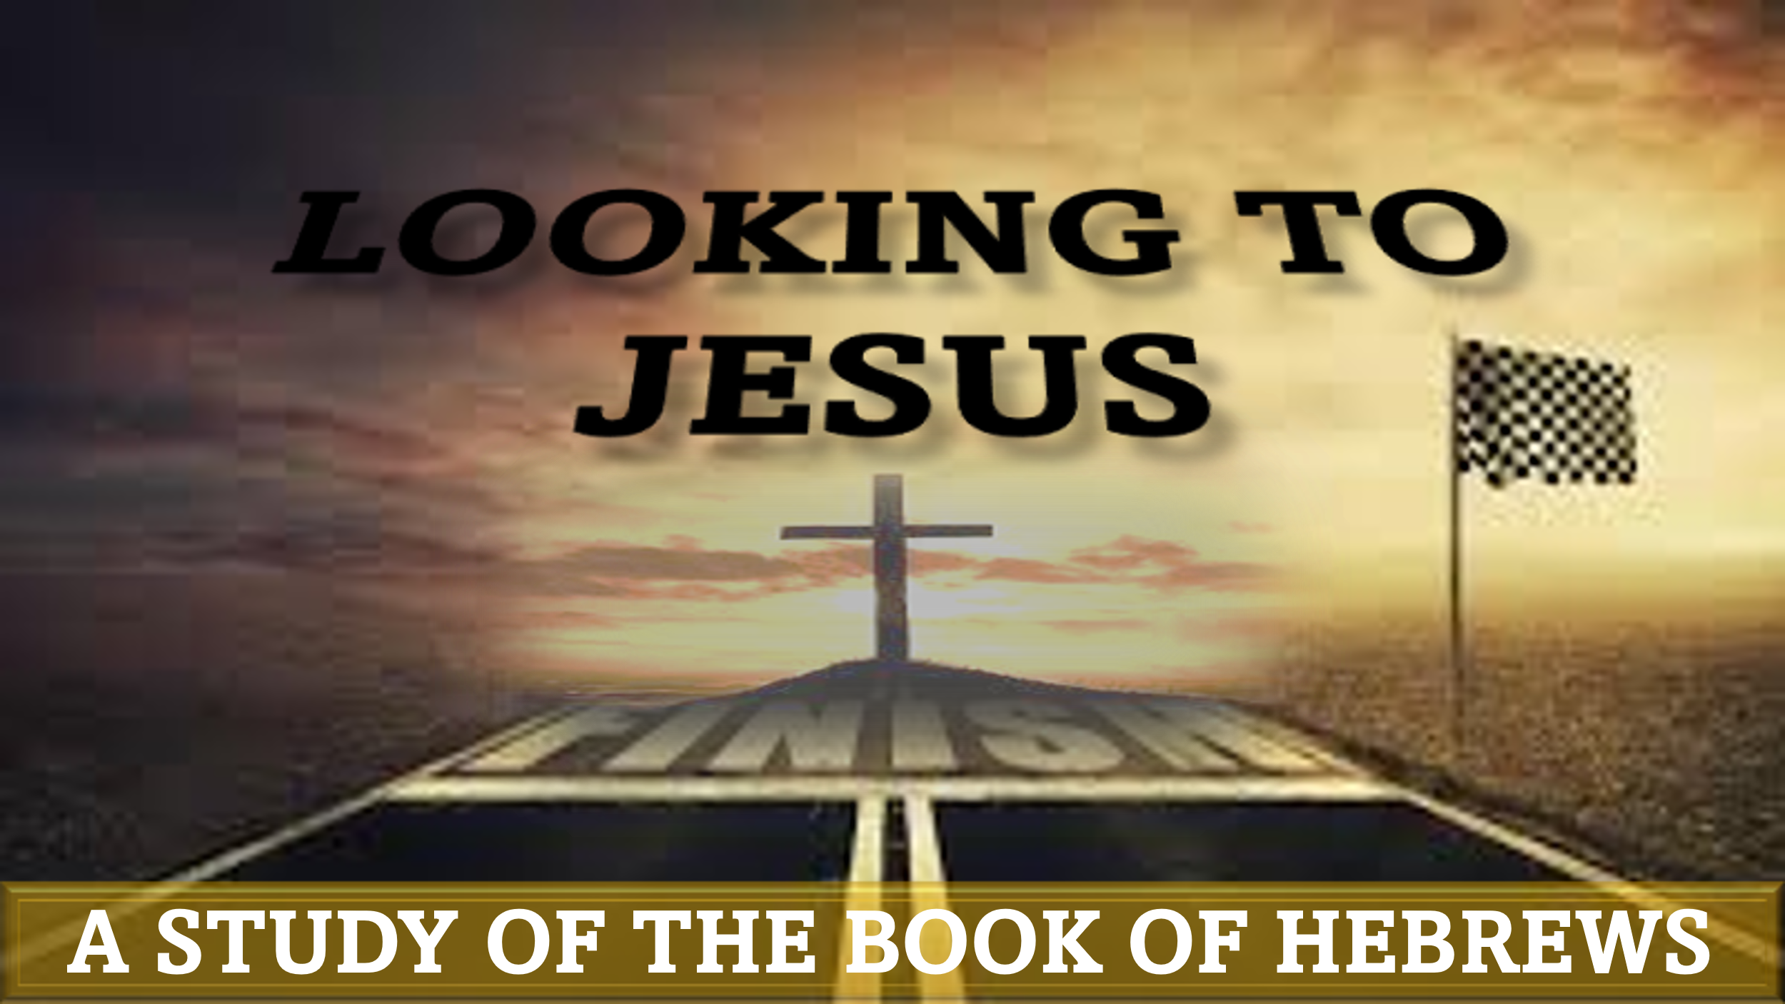

“By Faith: Seeing, but not receiving”
hebrews 11:13-16

“These all died in faith, not having received the things promised, but having seen them and greeted them from afar, and having acknowledged that they were strangers and exiles on the earth. For people who speak thus make it clear that they are seeking a homeland. If they had been thinking of that land from which they had gone out, they would have had opportunity to return. But as it is, they desire a better country, that is, a heavenly one. Therefore God is not ashamed to be called their God, for he has prepared for them a city.”

How would you react if someone told you that if you were obedient to God, your great-great-great…grandchildren and their descendants would be prosperous and powerful? Would you be overjoyed for your lineage that you will never meet, or would you prefer to experience these blessings yourself?

In our lesson tonight, we are encouraged to embrace a faith that obeys God – even when we may not be the direct beneficiaries of the reward for faithfulness. This requires an unselfish and long-range understanding of God’s ultimate plan.
Death in the Waiting Room – Hebrews 11:13a
On May 9, 2007, Elizabeth Rodriguez died due to a perforated bowel. What makes her story surprisingly tragic is the fact that she died while in the waiting room of the Emergency Department at MLK – Harbor Hospital in Los Angeles. This was after her family made 2 calls to 911 – while she was writhing in pain in the ER! This story is upsetting because Ms. Rodriguez went to the right place for treatment and most likely expected to be seen. Unfortunately, she died while waiting for the service she was hoping for.
Verse 13 explains that Abraham, Sarah, Isaac, and Jacob, all died without having received the fulness of the promise from God. On at least 4 different occasions, God promised Abraham possession, posterity, and prosperity (Genesis 12:7; 13:14-18; 15; 22:16-18). This does not include the various confirmations God gave to Isaac and Jacob in later years. Although none of them lived to see the manifestation of the promises, they eagerly “embraced” God’s word.
Question 1: How has modern theology affected our understanding of God’s plan and purpose?

Strangers in, but not of, the World – Hebrews 11:13b-15
Although Abraham fully understood that God’s promises were immutable, he also understood that they were not immediate. No matter where Abraham traveled, he knew he was not at home (Genesis 23:4 – see last week’s lesson). Likewise, we are never to get too comfortable here on earth. Jesus was keenly aware of our tendency to become too attached to this life, therefore he instructed us to store up treasure in heaven (Matthew 6:19-21).
Question 2: In what ways do we reveal our true heart regarding God’s heavenly promise?

“A Better Country” – Hebrews 11:16
The patriarch’s journeys no doubt exposed them to breath-taking landscapes, majestic wildlife, and interesting cultures. Regardless of what they experienced, we are informed that they always desired “a better country”. It is clear that their unfulfilled yearning was fueled by God’s promise. God had placed a seed in them that could not be germinated by the things of this world; only heaven could fully satisfy their longing (1 Corinthians 2:9).
Question 3: How can we increase our desire for heaven and decrease our desire for earth?

Application:
Our contemporary approach to faith has been dominated by earthly fulfilment (wealth, health, etc.). It will require spiritual-discipline and self-denial in order to restructure our priorities. Where is your treasure/heart?

“for where your treasure is, there will be your heart also” (Matthew 6:21)

