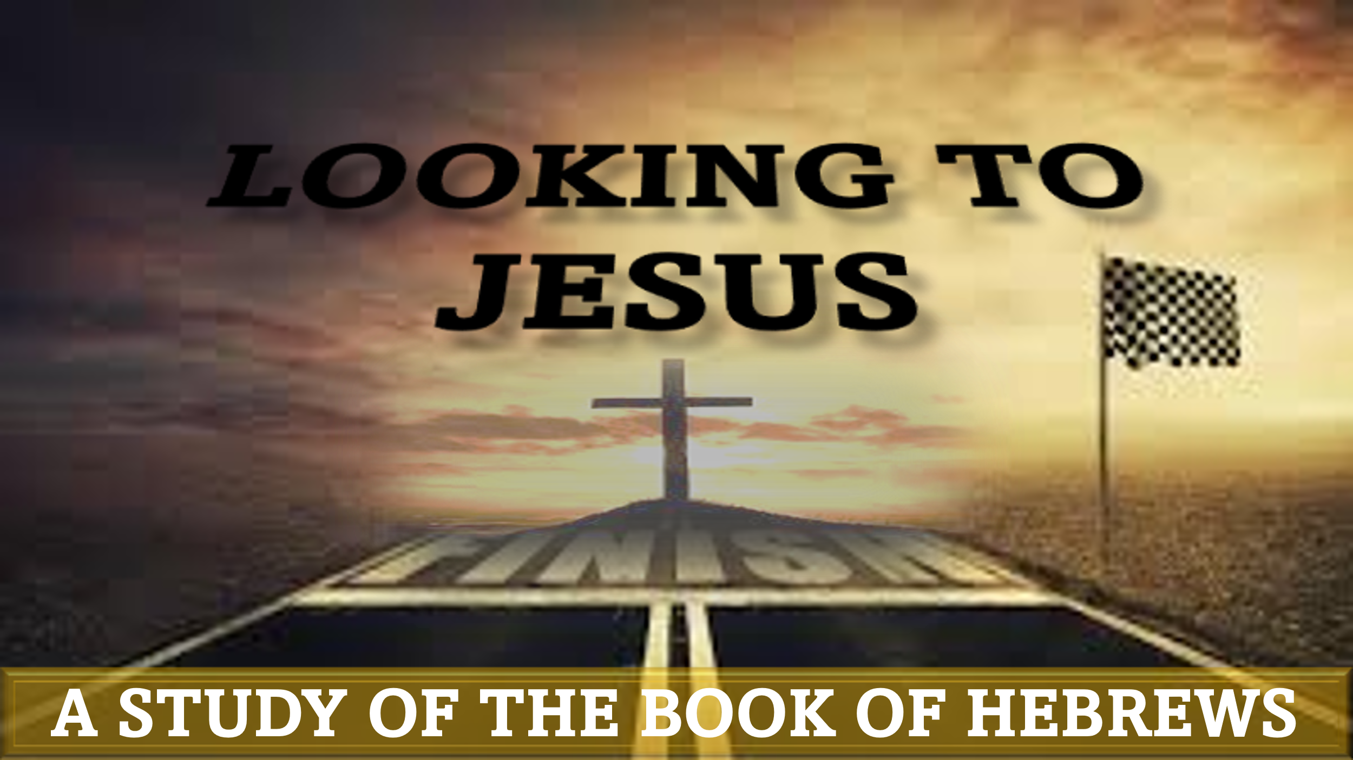

“Great faith: the family of faith”
hebrews 11:32-40

“And what more shall I say? For time would fail me to tell of Gideon, Barak, Samson, Jephthah, of David and Samuel and the prophets— who through faith conquered kingdoms, enforced justice, obtained promises, stopped the mouths of lions, quenched the power of fire, escaped the edge of the sword, were made strong out of weakness, became mighty in war, put foreign armies to flight. Women received back their dead by resurrection. Some were tortured, refusing to accept release, so that they might rise again to a better life. Others suffered mocking and flogging, and even chains and imprisonment. They were stoned, they were sawn in two, they were killed with the sword. They went about in skins of sheep and goats, destitute, afflicted, mistreated— of whom the world was not worthy—wandering about in deserts and mountains, and in dens and caves of the earth. And all these, though commended through their faith, did not receive what was promised, since God had provided something better for us, that apart from us they should not be made perfect.”
“We are family!” Many of us started humming this catchy tune as we read these words. If nowhere else, we hear this classic by Sister Sledge at family reunions, reminding us of our connection to those in attendance. As we reach the conclusion of the iconic 11th chapter of Hebrews, the writer culminates by explaining how our faith connects us to the men and women who are covered in the preceding verses.

Honorable Mention (Hebrews 11:32)
The author is nearing the conclusion of his review of men and women of faith from the past, whom he used to encourage the struggling saints to whom his letter was addressed presently. He apparently felt that he had sufficiently covered the major figures in biblical history, but did not want to be remiss in at least mentioning other figures who loomed large in the family of faith:
- Gideon (Judges 6-8) – “mighty man of valor” who led the defeat of the Midianites with 300 men
- Barak (Judges 4-5) – defeated Canaanites, led by Sisera – along with Prophetess Deborah
- Samson (Judges 13-16) – possessed unnatural strength – ultimately defeated Philistines in their temple
- Jephthah (Judges 11-12) – expelled son of a prostitute, defeated the Ammonites, made a fatal vow
- David (1 Samuel 16 – 1 Kings 2) – founder of messianic dynasty, psalmist, defeated many enemies
- Samuel (1 Samuel 1-25) – last judge of Israel. Defeated the Philistines, anointed Saul and David

Faith: the Power to Prevail (Hebrews 11:33-35a)
These verses cover the prevailing power of faith. God sometimes works through our faith to give us the power to prevail over circumstances in which we are outnumbered and overwhelmed. This aspect of faith typically leads to celebratory praise from the victors:
- Subdued kingdoms: Moses (Joshua 12:1-6); Joshua (Joshua 12:7-24); David (2 Samuel 8:1-14)
- Wrought righteousness (administered justice): Samuel (1 Samuel 7:3-17); David (2 Samuel 8:15)
- Obtained Promises: Abraham & Sarah (Genesis 21:1-7); Israel (Joshua 23:1-24:13)
- Stopped the mouths of lions: Samson (Judges 14:5-9); David (1 Samuel 17:34-37); Daniel (Daniel 6)
- Quenched the violence of fire: Hananiah, Mishael, Azariah (Daniel 3); Israel (Isaiah 43:2)
- Escaped the edge of the sword: David (1 Samuel 19-30); Elijah (1Kings 19:1-18)
- Out of weakness made strong: Samson (Judges 16:23-31); Hezekiah (2 Kings 20:1-11)
- Waxed valiant in fight: Israel (Exodus 17:8-16; Joshua 8:1-29); Gideon (Judges 7)
- Turned to flight armies of aliens: Israel (1 Samuel 17:47-53; 2 Kings 19:14-35)
- …Dead raised: Zarephath Widow (1 Kings 17:17-24); Shunammite (2 Kings 4:18-37)

When has God worked mightily through your faith to empower you to prevail?

Faith: The Power to Persevere – Hebrews 11:35b-38
While most people prefer faith to give them power to prevail in triumph. In fact, most testimonies we hear comprise of saints declaring miraculous healing, unlikely victories, and other stories of success. The next few verses explore the other side of faith: the power to persevere through trials:
- Tortured: Maccabees
- Mockings and scourgings: Jeremiah (Jeremiah 20:1-2)
- Bonds and imprisonments: Jeremiah (Jeremiah 37:11-38:13)
- Stoned: Naboth (1 Kings 21:1-16)
- Sawn asunder: Isaiah – according to legend
- Tempted: Elijah (1 Kings 19:1-18)
- Slain with the sword: Priests at Nob (1 Sameul 22:6-19)
- Wanderers…: Elijah & Elisha (1 Kings 19:19)
- Destitute, afflicted, tormented: Ezekiel (Ezekiel 4); Hosea (Hosea 1); Jonah (Jonah 4)

When has God given you power to persevere in faith through a difficult time?

Faith: Participation in the Promise – Hebrews 11:39-40
The chapter concludes by explaining the unifying power of faith. We are told that although ancient faith-walkers were blessed because of their faith, none of them realized the ultimate reward for their faith while they lived.
The complete realization of the promise was reserved until the “fulness of time” (Galatians 4:4). Jesus: the Divine Word made flesh (John 1:14), the Hope of Glory (Colossians 1:27), is the Mediator of the New Testament who qualifies us to receive the promise of eternal inheritance (Hebrews 9:15)
From Abel, to the contemporary Believers reading Hebrews around 65AD, to Christians reading in this age, the same faith connects those who have trusted in God since the beginning of time. In times of prevailing faith or persevering faith, we can take comfort in our inclusion in the family of God (Matthews 5:11-12; John 17:20-21, 20:29)

How do the accounts of the lives of Old Testament believers impact your faith journey?
Conclusion
We must remember that the purpose of chapter 11 is not to inform; it is to inspire! Connecting the end of chapter 10 and the beginning of chapter 12 to this chapter gives us a fuller picture of the intent of the author. Readers are encouraged not to shrink back in fear in the face of persecution (Hebrews 10:19-39); rather, we are to gain encouragement from the faithful examples of those who came before us (Hebrews 11). Our ultimate example is Jesus, who showed us how to endure adversity because of the promise we have yet to fully receive (Hebrews 12:1-3).
Genuine faith is like Vitamin C: not only does it protect (from free radicals that can lead to illnesses including cancer); it provides (by helping the body produce collagen, which helps with building and maintaining healthy bones, joints, and skin). Likewise, our faith protects us from sinful diseases that lead to a cancer of our soul, and provides the strength to produce a healthy spiritual life that pleases God.

Application: You can develop a stronger faith through the spiritual exercise of reading God’s Word and gaining strength from the testimonies of the saints – past and present. You are a part of the family of faith!

