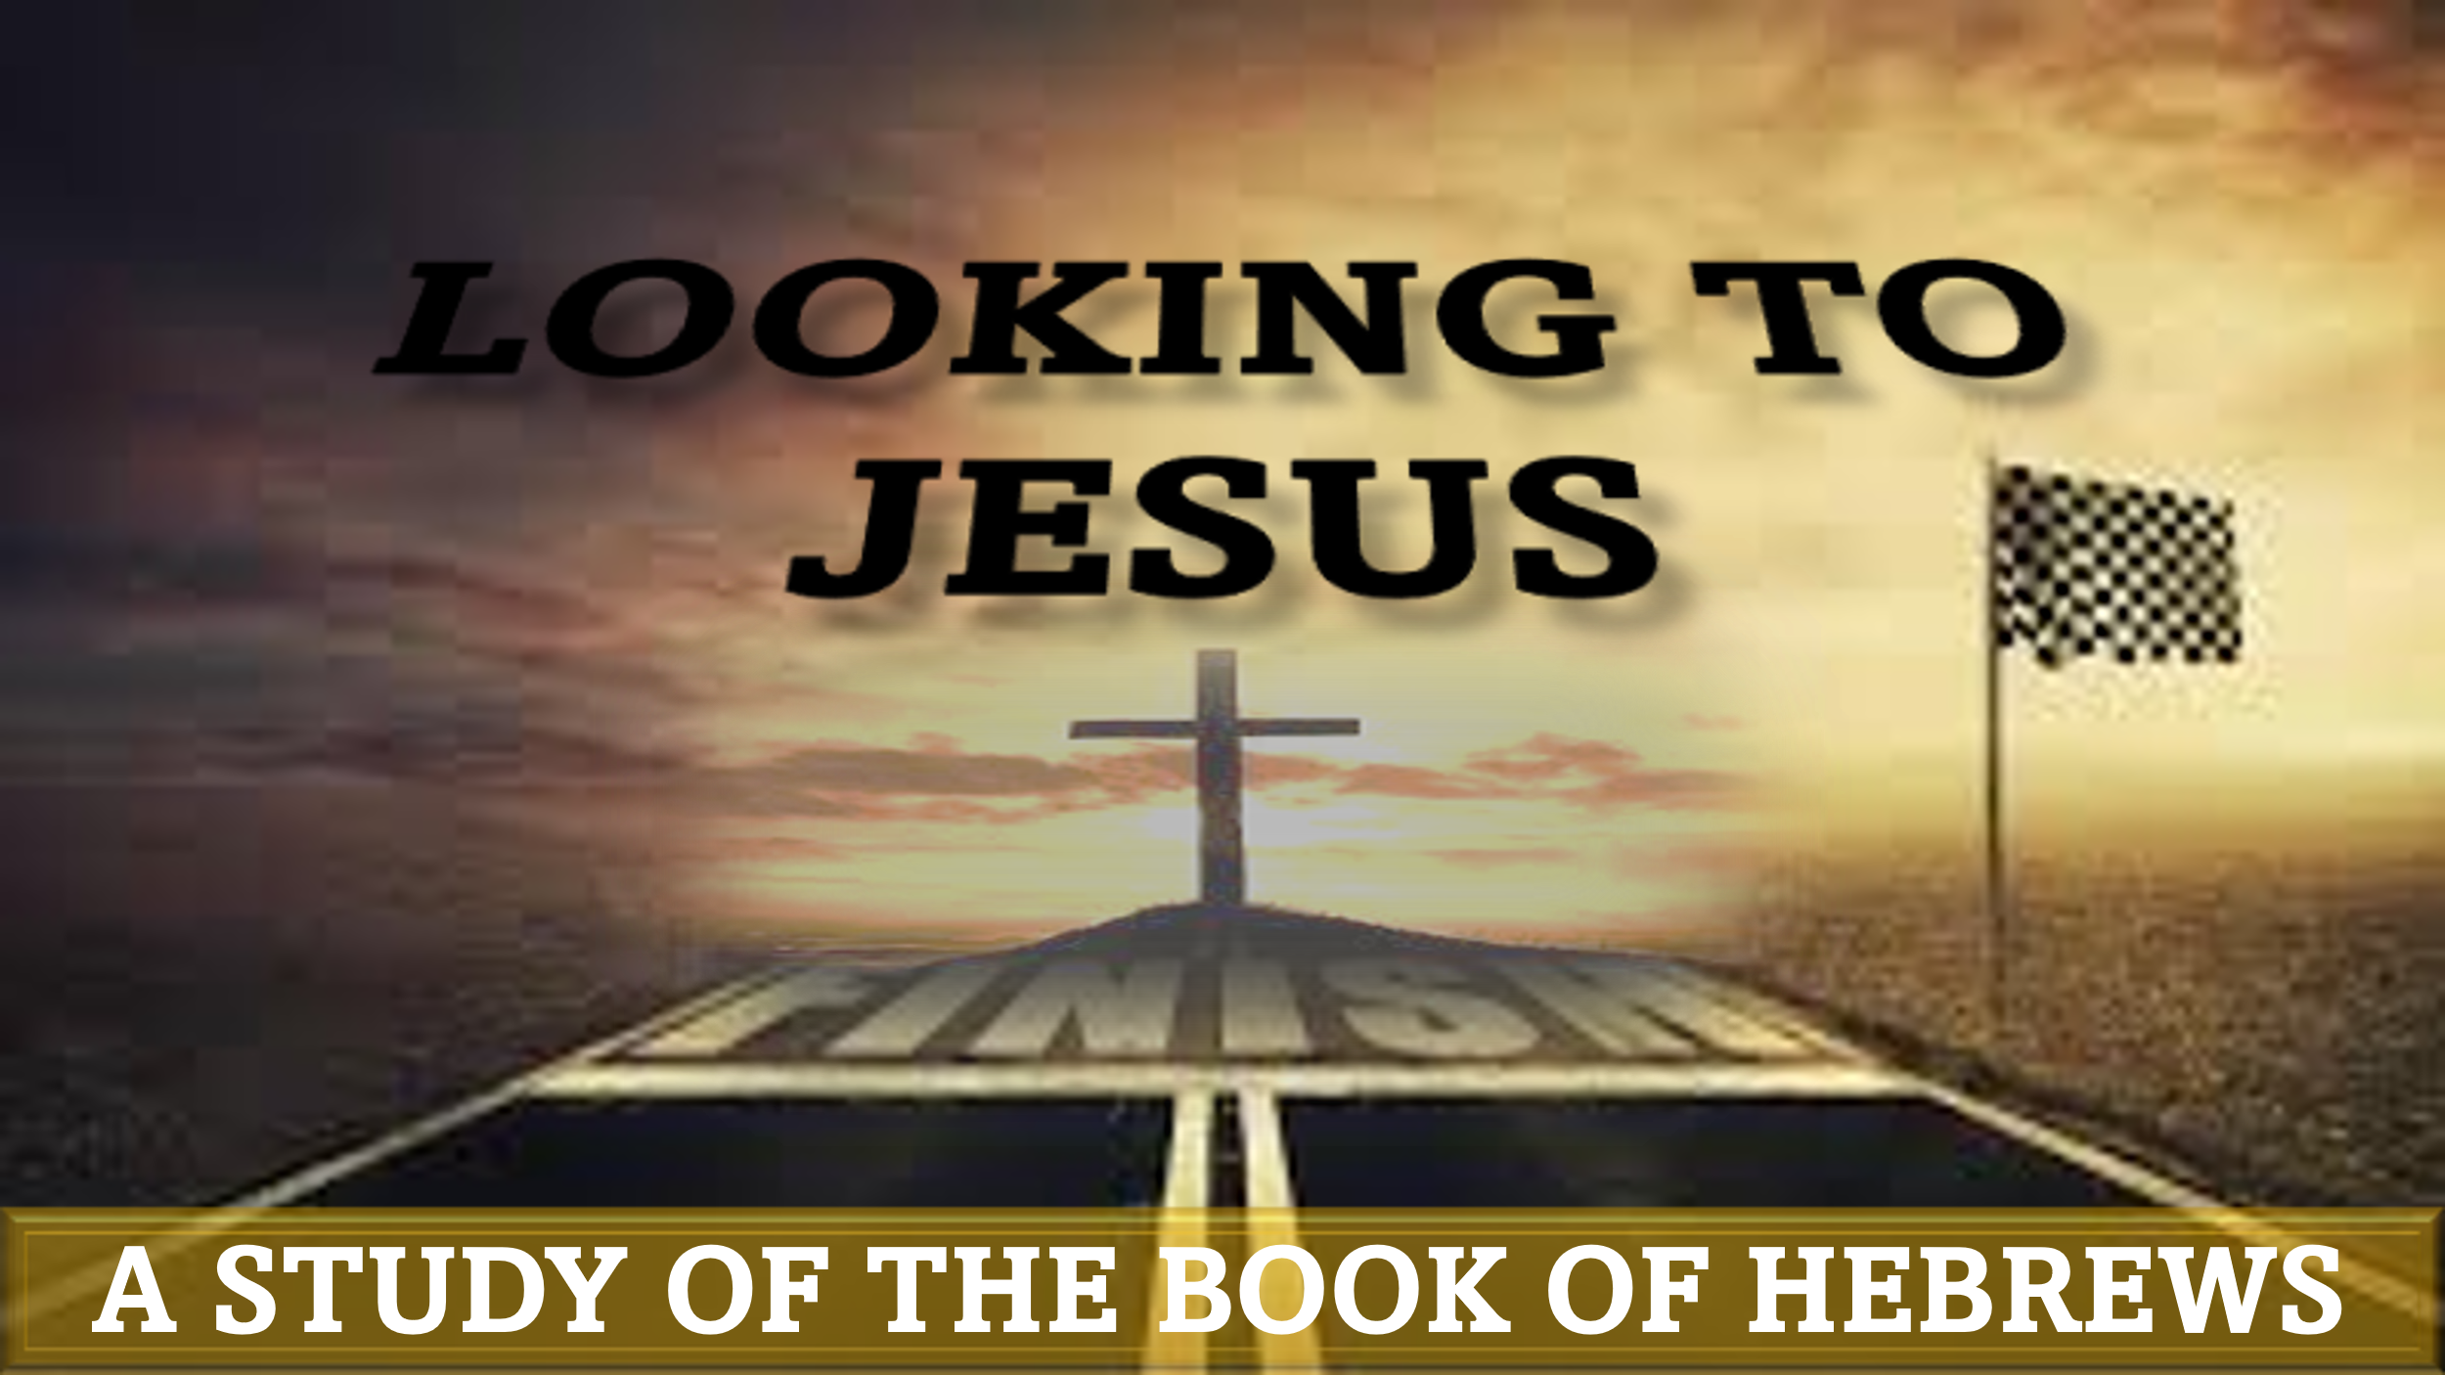

“By Faith: Abraham and sarah”
hebrews 11:8-12

“By faith Abraham obeyed when he was called to go out to a place that he was to receive as an inheritance. And he went out, not knowing where he was going. By faith he went to live in the land of promise, as in a foreign land, living in tents with Isaac and Jacob, heirs with him of the same promise. For he was looking forward to the city that has foundations, whose designer and builder is God. By faith Sarah herself received power to conceive, even when she was past the age, since she considered him faithful who had promised. Therefore from one man, and him as good as dead, were born descendants as many as the stars of heaven and as many as the innumerable grains of sand by the seashore.”

Are you willing to leave everything that is familiar to follow God? Do you believe God can do the impossible?

Tonight’s study of Abraham and Sarah will show us the rewards for trusting God – even when it doesn’t make sense!

Abraham’s Call – Hebrews 11:8-10; Genesis 11:27-12:9
According to the genealogical record in Genesis 5, Noah was the 10th descendant of Adam. Interestingly, Adam had only been dead 126 years when Noah was born. Noah’s father Lamech was 56 when Adam died, so it is very possible that Lamech was able to meet his great-great-great-great-great-great-grandfather in person!
Noah’s name means “rest”. His father gave him that name because he had hopes that God would bring relief from the gruesome toil of farming that came as a result of the curse (Genesis 3:17-19; 5:29). Noah was married and had three sons, Shem, Ham, and Japheth.
At the beginning of Genesis 6, we are told that humanity was growing increasingly wicked to the point that God regretted creating mankind. However, in the midst of great sin and evil, Noah found favor in God’s sight (Genesis 6:8)
Question 1: Why did God find pleasure in Noah?

God’s Promise to Abraham – Genesis 13:14-18; 15:1-21; 17:1-27
God revealed his plan to destroy most of humanity to Noah and commanded him to build an ark for him and his family. Remarkably, Noah obeyed God’s command without question – even though it is very likely that Noah had never seen a boat or even rain! (Genesis 6:22, 7:5)
The flood and its aftermath lasted for over 1 year. In addition to the rain, the bible states God also caused “the fountains of the great deep” to “burst forth” (Genesis 7:11). This resulted in water covering the tops of mountains for 150 days (Genesis 7:24)
Question 2: How did Noah’s faith affect his family?

Sarah’s “Eventual” Faith – Genesis 18:1-15; 21:1-7
After Noah and his family exited the ark, he offered sacrifices of some of the clean animals that were on the ark. Later, God shows how much He values life by forbidding Noah to eat live animals or to kill another human (Genesis 9:2-6). God also made a covenant with Noah that He would never again destroy the earth by flood (Genesis 9:8-17). The last account we read of Noah is of him cursing his grandson Canaan after he was discovered unclothed in his tent in a drunken state (Genesis 9:18-29).
Question 3: How does Noah’s “incident” change God’s view of him?

Application:
God was pleased with Noah before Noah obeyed the command to build the ark. It was Noah’s faithful life that led God to choose and use him. Even when Noah lost control after drinking, God still honored his faithfulness. How can you live your life so that it gets God’s attention in a good way?

